**Dicrete wavelet transformation**

clc;

clear all;

close all;

A = imread('C:\Users\Public\Pictures\Sample Pictures\b.jpg');

[R,C,D] = size(A);

if(D==3)

A = rgb2gray(A);

else

A = A;

end

x = imresize(A,[256 256]);

[xa,xh,xv,xd] = dwt2(x,'haar'); % APPLYING HAAR WAVELET TRANSFORM

fprintf('DISCRETE WAVELET TRANSFORM')

fprintf('\n');

fprintf('1.FIRST LEVEL DECOMPOSITION 2.SECOND LEVEL DECOMPOSITION')

fprintf('\n');

K = input('ENTER CHOICE FOR WAVELET TRANSFORM :-');

fprintf('\n');

switch K

case 1

figure(1);

subplot(2,3,1);

imshow(x);title('ORIGINAL IMAGE');

subplot(2,3,2);

imshow(xa/255);title('APPROXIMATE IMAGE');

subplot(2,3,3);

imshow(xh);title('HORIZONTAL IMAGE');

subplot(2,3,4);

imshow(xv);title('VERTICAL IMAGE');

subplot(2,3,5);

imshow(xd);title('DIAGONAL IMAGE');

% 1st LEVEL TRANSFORM

Y = [0.003*xa log10(xh)*0.3 ; 0.3*log10(xv) 0.3*log10(xd)];

% COMBINING ALL DETAILS

figure(2);imshow(Y);

title('1st LEVEL WAVELET DECOMPOSITION');

case 2

[xaa,xah,xav,xad] = dwt2(xa,'haar');

figure(1);imshow(xa/255);title('APPROXIMATE IMAGE');

figure(2);imshow(xaa/255);title('APPROxIMG-2nd LEVEL DECOMPOSITION');

figure(3);imshow(xah);title('HORIZONTAL APPROX IMAGE');

figure(4);imshow(xav);title('VERTICAL APPROX IMAGE');

figure(5);imshow(xad);title('DIAGONAL APPROX IMAGE');

% 2nd LEVEL TRANSFORM

Y1 = [0.003*xaa log10(xah)*0.3 ; 0.3*log10(xav) 0.3*log10(xad)];

% COMBINING ALL DETAILS OF 2nd LEVEL TRANSFORM

figure(6) ;

imshow([Y1 xh*0.05 ; xv*0.05 xd*0.05 ]);

% 2 – LEVEL WAVELET TRANSFORM

title('2nd LEVEL WAVELET DECOMPOSITION');

otherwise

fprintf('ENTER CORRECT CHOICE');

end

OUTPUT :

DISCRETE WAVELET TRANSFORM

1.FIRST LEVEL DECOMPOSITION 2.SECOND LEVEL DECOMPOSITION

ENTER CHOICE FOR WAVELET TRANSFORM :-1

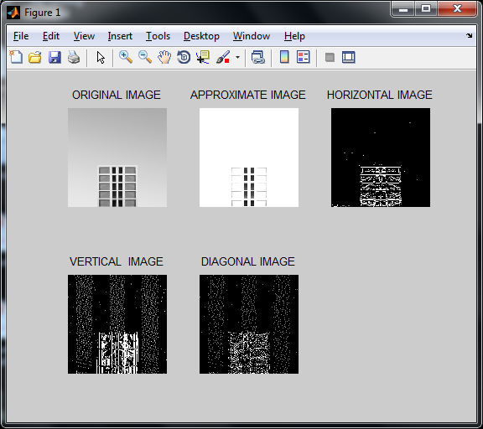

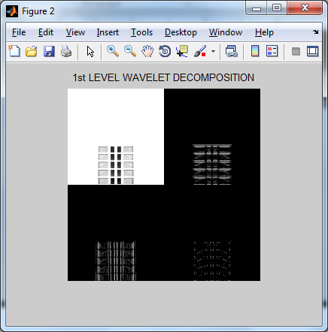

DISCRETE WAVELET TRANSFORM

1.FIRST LEVEL DECOMPOSITION 2.SECOND LEVEL DECOMPOSITION

ENTER CHOICE FOR WAVELET TRANSFORM :-2

